P425/1
Mathematics
Paper 1
July/August 2019
3hours

BUGANDA EXAMINATIONS COUNCIL MOCKS

Uganda Advanced Certificate of Education

MATHEMATICS

PAPER 1

3HOURS

INSTRUCTIONS

- Answer all the eight questions in section A and only 5 questions from section B.
- Any additional question(s) answered will not be marked.
- All working must be shown clearly
- Begin each answer on a fresh sheet of paper.
- Silent, non-programmable scientific calculators and mathematical tables with a list of formulae may be used.

SECTION A (40 MARKS)

- If 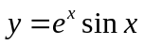, show that 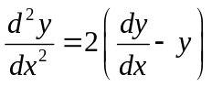. (5marks)
- Given that 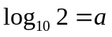, prove that 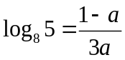. (5marks)
- Solve by echelon method the following set of simultaneous equation:
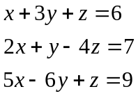 (5marks)
- Partialise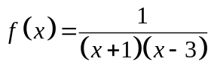 hence evaluate 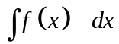. (5marks)
- Form the equation of the circle which passes through A(1, 3) B(3, 5) and C(5, 3) in the form x² + y² + 2fx + 2gy + c = 0 hence state its centre and radius. (5marks)
- Solve the equation (5marks)
7(i) In how many ways can the letters of the word GEOMETRY be arranged in a row?
(ii) In how many of these arrangements are the two E’s together? (5marks)
8. The second, fourth and eighth terms of an AP are in a GP. The sum of the third and fifth terms is 20. Determine the first three terms of the AP stated above. (5marks)
SECTION B (60 MARKS)
9a) If x is small enough so that terms in x³ and higher powers may be ignored, use binomial expansion to show that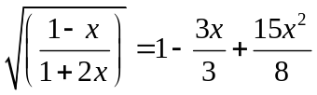. (8marks)
b) Expand by use of Maclaurin series up to the term in x² the function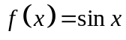. Hence evaluate sin30⁰ to 4 decimal places. (4marks)
10a) Initially, the number of bacteria present in a culture solution is N_{o}.
At time t = 1hour, the number of bacteria is measured to be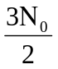. The rate of growth is assumed to be proportional to the number of bacteria present at any time t. Show that the time necessary for the bacteria to grow to 3N_{o}
(triple the original) is approximately 2.7hrs. (6marks)
b) A small metal piece initially at 20⁰C is dropped into a large container of water kept at 100⁰C. It was observed that the temperature of the metal increased by 2⁰C in one minute.
  - How long will it take for the temperature of the metal to increase to 90⁰C?
  - Find the temperature of metal after 20minutes. (6marks)
11. Evaluate the following:
(i) 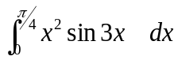 (4marks)
(ii) 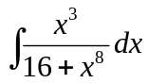 (4marks)
  - 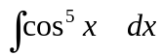 (4marks)
12a)(i) Form the equation of the plane perpendicular to line 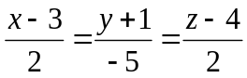 passing through a point A(5, -6, 6). (4marks)
(ii) Determine the point B where the formed plane meets the line in (i) above. (4marks)
b) Determine the shortest distance from the point P(2, -5, 3) to the line 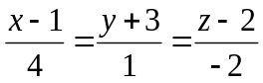. (4marks)
13a) Prove that 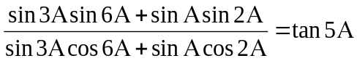. (4marks)
b) Show that 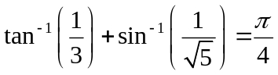. (4marks)
c) Solve for θ in the range 0 ≤ θ ≤ 2π if 4cosθ + 3sinθ = 5. (4marks)
14. Sketch the following curve systematically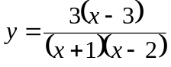. (12marks)

15a) Determine the square root of the complex number 15 + 8i. (4marks)
b) Solve the equation z⁴ + 6z² + 25 = 0 (4marks)
c) Evaluate 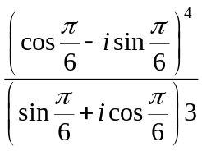 and give the solution in modulus-argument form. (4marks)
16. Prove that the tangent to the parabola 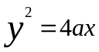 at the points
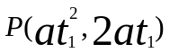and Q(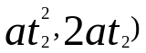 meet at a point T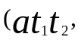a (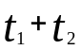)

(ii) If M is the midpoint of PQ, prove that TM is bisected by the parabola.
(iii) If P and Q vary on the parabola in such a manner that PQ is always parallel to the fixed line y = mx, show that T always lies on the fixed line parallel to the x-axis.

END

